April 15, 2022

To: Randy Smith, Vice Provost for Academic Programs

From: Eugenia Romero, Director of Undergraduate Studies, SPPO

RE: Request to Remove the Hispanic Studies Concentration from the Spanish Major

Dear Randy,

As the Director of Undergraduate Studies in the Department of Spanish and Portuguese, I write to request to officially withdraw the Hispanic Studies Concentration from the Spanish Major, effectively immediately. Originally, this concentration was created during semester conversion in 2012, when we had the opportunity to restructure the major into three specific tracks: Iberian Literatures and Cultures, Latin American Literatures and Cultures, and Hispanic Linguistics. The Hispanic Studies Concentration was created to ensure that students that didn’t have all the requirements for the other three concentrations, once we switched to semesters, were still able to finish their degree. However, in practice this track has never been followed by any student. In fact, students have been able to fulfil their specific concentration requirements without any issues. Furthermore, beginning in Autumn 2022, our Spanish Major will have a fourth concentration: Latinx Literatures and Cultures. Therefore, the Hispanic Studies Concentration is now obsolete and unnecessary.

Respectfully,

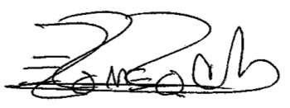

Dr. Eugenia R. Romero
Associate Professor of Iberian Studies
Vice-Chair and Director of Undergraduate Studies
Department of Spanish and Portuguese
The Ohio State University
romero.25@osu.edu

